Flood Information Certificate
Date: 20/02/2024 Created by: anuph

[CLIENT_ORG]
[CLIENT_ADDR1]

Attn: [CLIENT_NAME]
Dear Sir/Madam,

Property: | LOT 7010 : SEC : DP 93327  {PROP_DP}
Address:

The information supplied in this certificate represents the most current flooding information held by Council at the time the certificate was created.

Please find attached flood information maps prepared in relation to the land subject to your enquiry. The maps have been prepared using data related to 1% AEP flood event as identified by Council’s 2018 Flood Risk Management Study and Plan prepared by Royal Haskoning DHV. Information related to the 5% AEP flood event is also included in the tables accompanying the maps.

Maximum and minimum flood depth information included in the table accompanying the maps has been informed by LIDAR data held by Council in relation to the height of natural ground level at the site. The accuracy of LIDAR data or flood depth information for the site should not be relied on to inform the preparation of a development application for the site or any decision making related to the management of flood risks at the land. Council LIDAR data has been prepared on a Shire wide basis and may be inaccurate at particular sites or where cut and fill has occurred.

Accordingly, it will be necessary for a person using this information for the purpose of preparing a development application to engage Registered Surveyor to determine the actual natural surface levels, and flood depth information to AHD on the site to determine the extent of inundation. Any person using this information to inform the preparation of a development application should also review Section 13 of the Muswellbrook Development Control Plan which includes controls relevant to the development of flood prone land
If you require any further clarification in relation to the above please contact Council’s Planning, Environment and Regulatory Services Team on 02 6549 3745.

Yours Faithfully

SIGNATURE

_______________

[POSITION]

Definitions | Hazard Vulnerability Classification
AEP is the probability of an event being equaled or exceeded within a year. Typically the AEP is estimated by extracting the annual maximum in each year to produce an Annual Maxima Series (AMS);  Flood Level elevation of the flood surface above Australian Height Datum (AHD)  Depth is based on 2013 LiDAR aerial survey data  Velocity is the speed of the flowing flood water  Hazard is Hazard Vulnerability Classification as outlined in Section 7.2.7 of Australian Rainfall and Runoff 2016. Maximums relate to the highest value on the property parcel. See table below for further information. | H1 Generally safe for vehicles, people and buildings.  H2 Unsafe for small vehicles.  H3 Unsafe for vehicles. Children and the elderly.  H4 Unsafe for vehicles and people.  H5 Unsafe for vehicles and people. All buildings vulnerable to structural damage. Some less robust buildings subject to failure.  H6 Unsafe for vehicles and people. All building types considered vulnerable to failure.

Fig 1: Flood Level Map 1% AEP 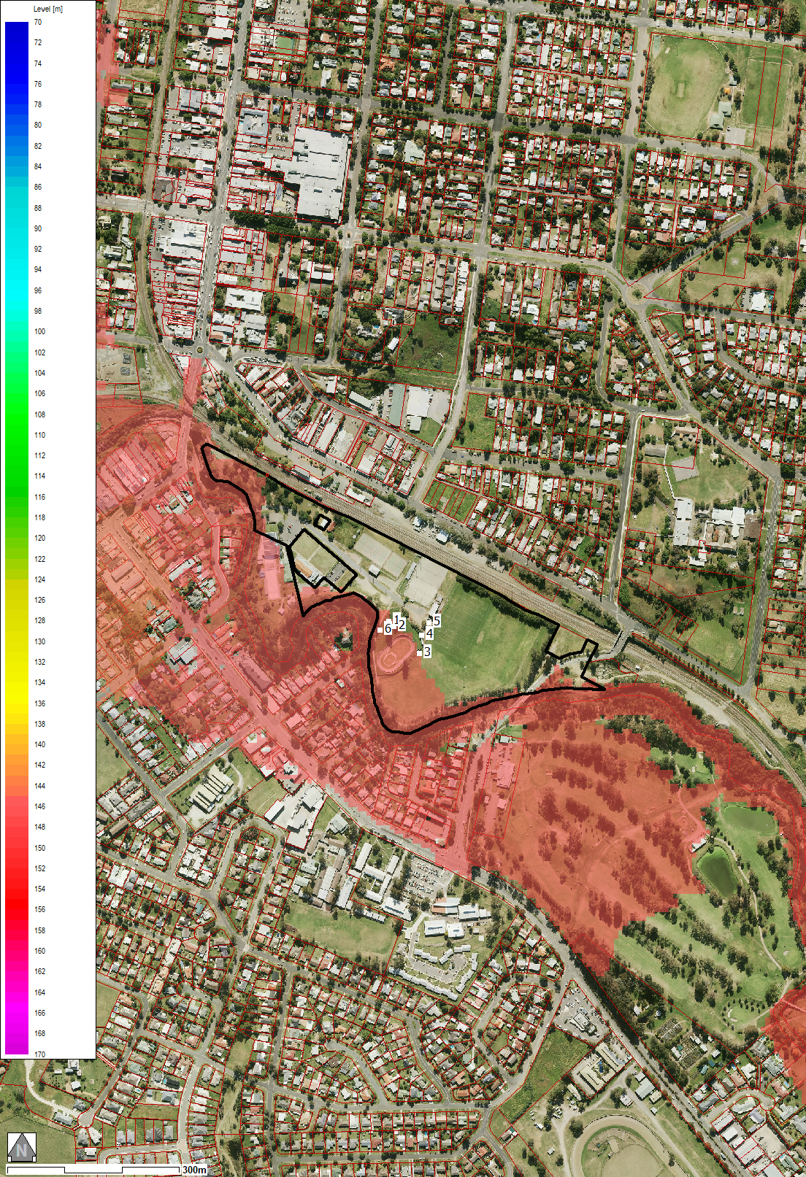 | Fig 2: Flood Velocity Map 1% AEP 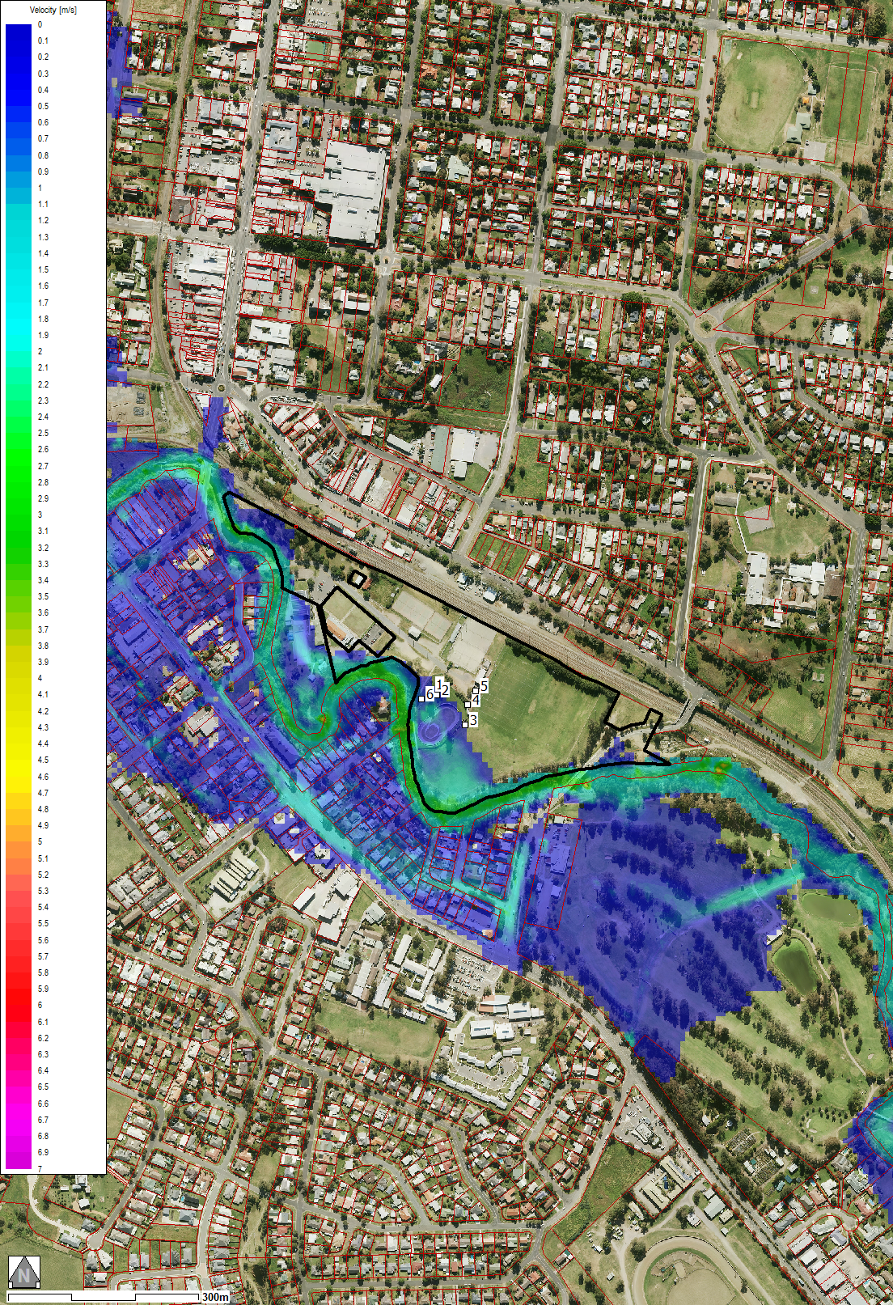 | Fig 3: Flood Hazard Map 1% AEP 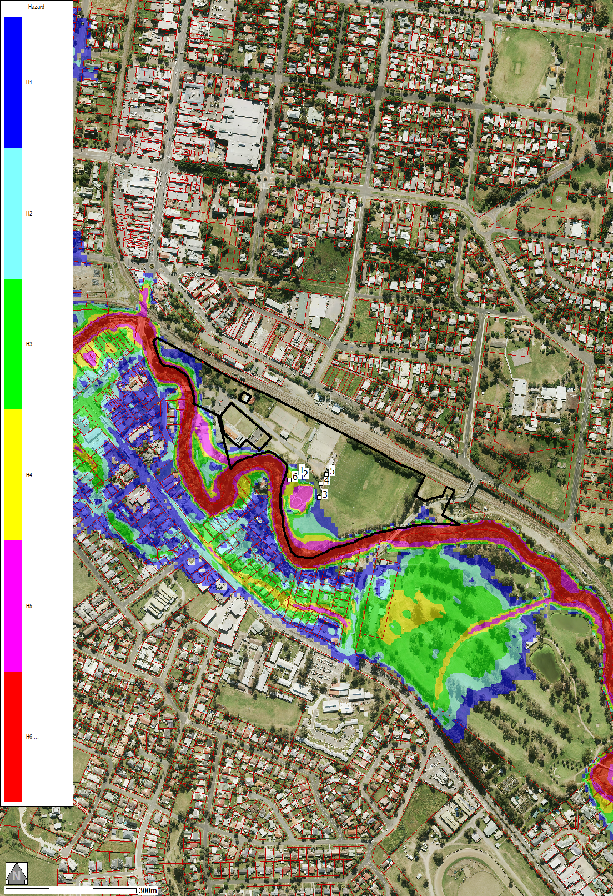

Table 1: Maximum and Minimum data Table 2: Key Point location flood data
Flood Information | 5% AEP Flood Data | 1% AEP Flood Data
Max. Water Level (m AHD) | 146.92 | 147.67
Min. Water Level (m AHD) | 144.72 | 145.21
Max. Velocity (m/s) | 3.49 | 3.60
Min. Velocity (m/s) | 0.04 | 0.02
Max. Depth (m) | 7.12 | 6.98
Min. Depth (m) | 0.04 | 0.02
Location | 5% AEP  Level | 5% AEP  Velocity | 5% AEP  Hazard | 1% AEP  Level | 1% AEP  Velocity | 1% AEP  Depth | 1% AEP  Hazard
1 | 145.18 | 0.13 | H1 | 146.05 | 0.17 | 0.83 | H3
2 | N/A | N/A | N/A | 146.05 | 0.33 | 0.45 | H2
3 | N/A | N/A | N/A | N/A | N/A | N/A | N/A
4 | N/A | N/A | N/A | N/A | N/A | N/A | N/A
5 | N/A | N/A | N/A | N/A | N/A | N/A | N/A
6 | 145.18 | 0.46 | H4 | 146.05 | 0.57 | 1.94 | H4

